

**Тестовое задание для QA-инженера**

1. **Изменить внешний вид корзины, используя параметр data-layout**

Значения данного параметра могут быть такими:   
BIG_ICON_DETAILS_SUBTOTAL  
TITLE_COUNTER   
etc

Виджет корзины:

<div class="ec-cart-widget"></div>

<div>

<script data-cfasync="false" type="text/javascript" src="https://app.ecwid.com/script.js?9967568&data_platform=code&data_date=2019-10-24" charset="utf-8"></script>

<script type="text/javascript">Ecwid.init();</script>

</div>

Ожидаемый итог: HTML-страница с измененной корзиной и списком всех доступных параметров

**Решение**: <http://thetester.ultimatefreehost.in/?i=1>

1. **Найти баг на странице https://my.ecwid.com/cp/**

Любой, чем критичней — тем лучше.

(уделите больше внимания к полям ввода, как при логине, так и при регистрации и восстановлении пароля)

1. **Possibility to skip 2-4 registration steps while creating a new Ecwid account.**

*Steps to reproduce:*

1 - Open the page https://my.ecwid.com/cp/

2 - Click to “Create a new Ecwid account” down below in the “Sign in to your Ecwid account” form.

3 - Fill in “Full name”, “Email” and “Password” bars by valid values, email must be not registered before.

4 - Push “Next: set up your Store” button.

5 - When https://my.ecwid.com/store/60576822#complete-registration loaded, we can see that the 1st step of registration is completed. There aren’t “skip” buttons on the page.

6 - Modify the URL of that page to https://my.ecwid.com/ and press Enter key. After that we have on email 2 letters “Confirm email” and “Ready to get started?”

7 - We on https://my.ecwid.com/store/60576822#dashboard:wizard=tiles and our account signed in, without complete 3 of 4 registration steps.

*Severity: Major*

1. **“Space” key is valid for password in registration form.**

*Steps to reproduce:*

1 - Open the page https://my.ecwid.com/cp/

2 - Click to “Create a new Ecwid account” down below in the “Sign in to your Ecwid account” modul.

3 - Fill in “Full name” and “Email” bars by valid values, email must be not registered before.

4 - Enter six “space” keys as password into “Password” bar.

5 - Appear green frame and check mark in "Password" bar. What means that it's a valid value.

6 - Push “Next: set up your Store” button. And you successfully go to the next step of registration.

*Severity: Major*

1. **The inside name of “password” bar visually conflicts with the typed password in the registration form.**

*Steps to reproduce:*

1 - Open the page https://my.ecwid.com/cp/

2 - Click to “Create a new Ecwid account” down below in the “Sign in to your Ecwid account” modul.

3 - Fill in “Password” bar 6 characters.

4 - Click outside of the “password” bar. You can see how the name of the bar conflicts with typed text.

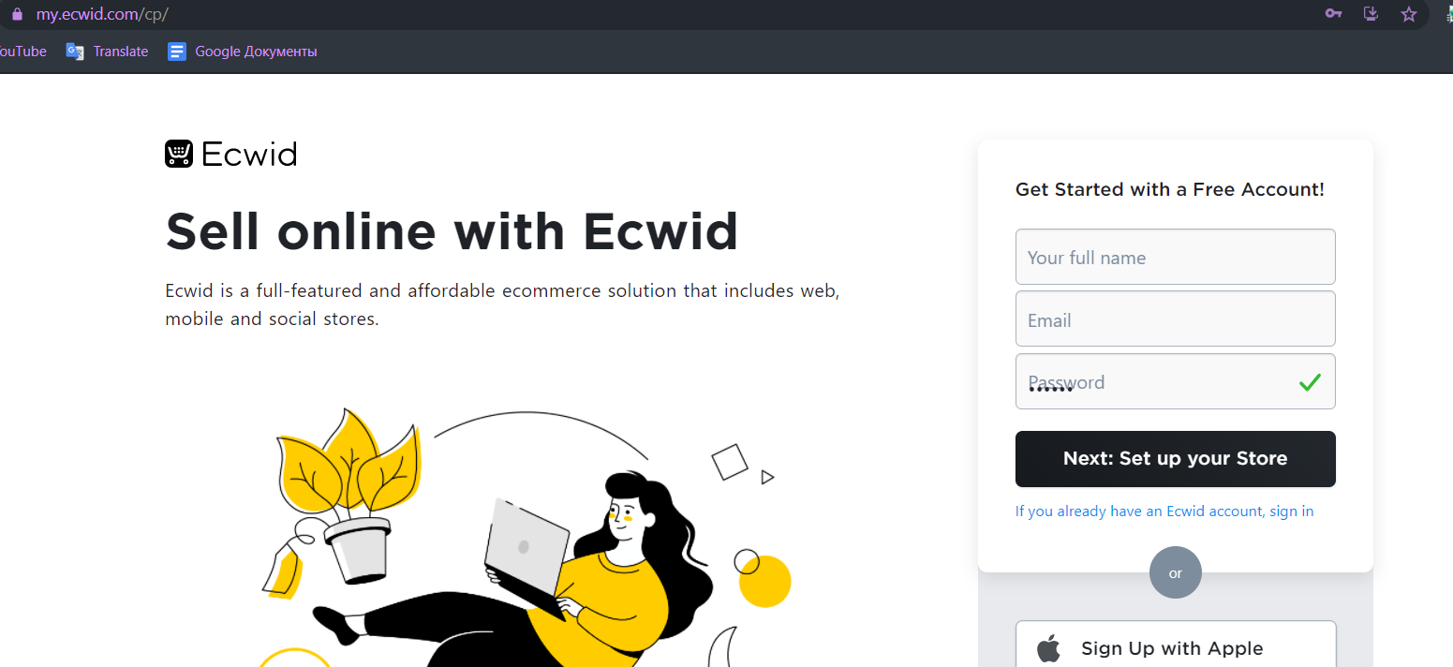

*Severity: Minor*

1. **“Password” bar has no limitation for the number of characters.**

*Steps to reproduce:*

1 - Open the page https://my.ecwid.com/cp/

2 - Click to “Create a new Ecwid account” down below in the “Sign in to your Ecwid account” modul.

3 - Fill in the “Password” bar full of “War and peace” by L. Tolstoy txt format.

Note: In a few minutes (depends on your hardware), the “password” bar will highlight with a green frame and check mark.

*Severity: Major*

**3.** С помощью JavaScript изменять язык на https://my.ecwid.com/cp/

В этом задании не нужно знать JavaScript на среднем или высоком уровне. Главное — исследовать и понять, как именно меняется язык и нагуглить скрипт в 1-2 строки.

Ожидаемый итог — JS-скрипт, который при вставке в консоль браузера изменит язык на my.ecwid.com

// Show all cookies to find something about language.

alert(document.cookie)

// There is “lang=ru;” that means we can change the value to en(english), or es(spanish) e.c.

document.cookie = "lang=en";

// reload the page to see result

location.reload()